Python Programming Lab: “Calc” (calculations)
For this lab, the requirements are:
- Your program shall ask the user to enter at least one string input and at least 2 numeric inputs. Prompt the user for each input, so that they know what they are supposed to input.
- Each of the numeric inputs shall be converted from string to number (as shown in the PowerPoint slides) so that you can perform math on the numbers. You will put this (conversion) code inside of a try/except block so that if the user does not enter a number, you can provide a user friendly error message, instead of allowing the program to abort and give an “unfriendly” message.
- Your program shall declare at least one numeric "constant" (just means that you use all caps when you name it and make sure you never change that value anywhere in the program).
- Your program shall perform some calculation using all the input numbers and the constant(s).
- Your program shall display and label whatever was input by the user, as well as whatever your program calculated, plus an explanation of the calculations that were made. An example explanation: “The final total is calculated as [the number of items times the price] less the discount”.
- Optional: you may use turtle graphics if you like, but this is not required. For example, you might ask the user how big a circle they want to have drawn.
- You shall use good programming style:
  - Naming:
    - Create (self documenting) variable names that describe what the variable holds and use camelCase. For example, a variable named myVariable is not self documenting because the variable name provides no clue as to what the variable holds.
    - Create (self documenting) names for variables that we will use as “named constants” and use ALL_CAPS.
  - Comments:
    - Add comments at the top of your program to indicate your name, a program description, and date written.
    - Group your python statements according to function. Put a blank line between groups and add “paragraph” style comments before each group of statements.
Homework submission:
- Create a word (or wordpad) document naming it with your last name and “calc”.
  - Run your program twice with all good data – using a different set of input values the second time.
  - Then run your program once with bad data (non numbers where numbers were expected). Because you used try/except, your program will give a “user friendly” error message, and not abort.
  - Paste a screen capture of all 3 runs into the document. (Remember that to get a screen capture, you do Alt-PrtSc then paste into the document.)
  - At the end of the document, copy/paste your python source code.
- Attach the word document and your python program to blackboard.
- IF you decided to use turtle graphics and it relies on resources, such as image file(s), submit a zip file of the folder that holds your program and the resources.
- Suggestion: choose a partner. You both do the assignment individually, but then you check the other's work to make sure all requirements have been met. This should ensure that you both get 10 out of 10 points. It also makes programming more fun when you work with a friend.
Example:
Here is a sample program that meets all these requirements. However, please be aware that you will lose points if your lab homework is too similar to this code or any code that was demonstrated in class or that is uploaded into blackboard (sample code or code from PowerPoint slides).

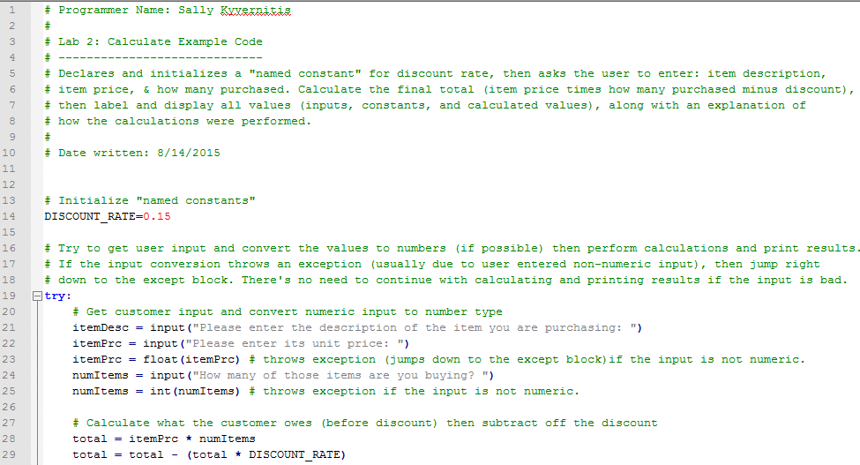
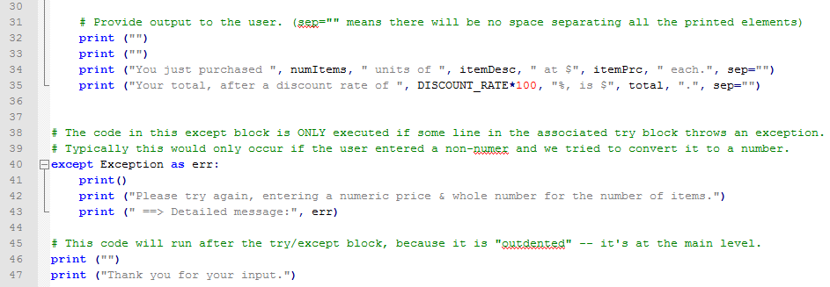

Note the syntax for print statements.
Inside the parentheses, you can put any number of items , separated by commas. Each item must either be a character string (e.g., something inside a pair of double quotes) or a variable/named constant that has a value. When the print statement executes, it prints whatever you put inside your double quotes, and it prints the VALUE of the variables. The last item (sep=””) just means for python not to put a space between all of the items, so you have more control over what you are printing.

